Addendum 2

Future Outlook
Our 2024 local plan had the health sector dominating the job market in Essex County. Current data suggests manual labor has slightly more job openings. This may be attributable to the marked increase in warehousing, which has been driven by e-commerce growth. The state has seen a 17% increase in warehouse space over the last decade. Finance, healthcare, and technology are the main areas of growth in the county’s economy. We continue to work with different industry sectors to identify their workforce needs and effectively support them with our work-based learning programs to increase the job skills of employees and make them eligible for potential promotional opportunities and growth.

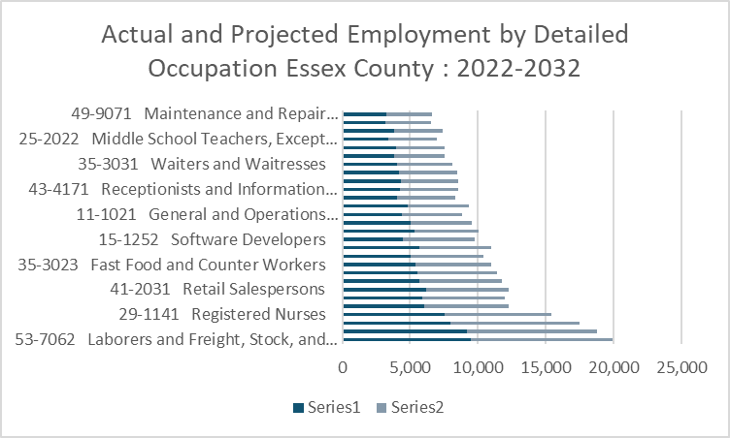
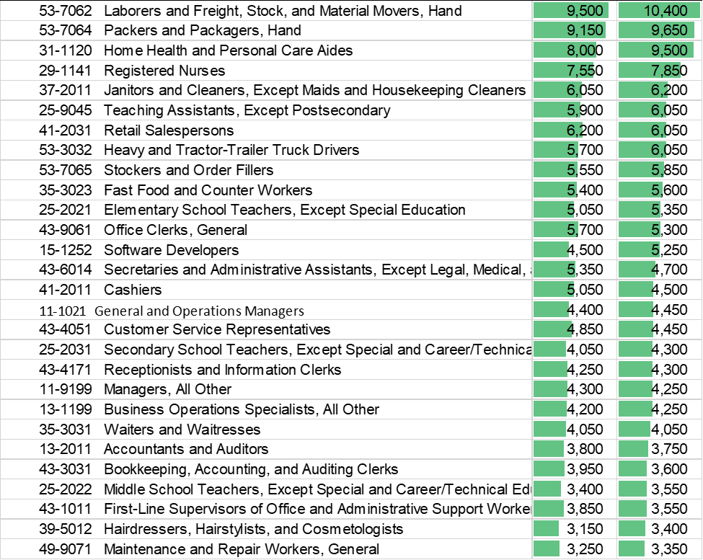
The above data further suggest that healthcare, finance, and technology remain areas of growth, as identified in our 2024 Local plan are still relevant.

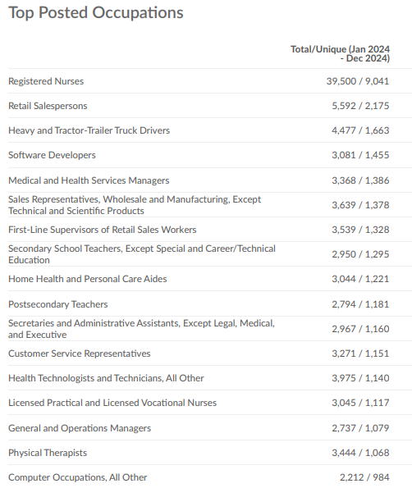

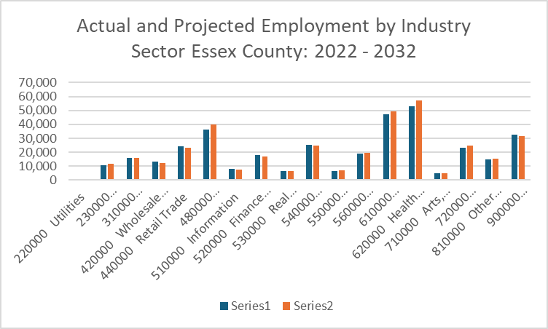

The growth of the Transportation and Warehousing industry sector will be addressed with appropriate training of individuals to fill the anticipated surge. The continuous growth in the healthcare and education sectors will require increased collaborations with institutions to meet talent acquisition needs.

Technological Growth and Changes
We continue to monitor the ubiquitous impact of technology on the employment terrain in the county. Though transportation and material moving Occupations continue to show growth it remains to be seen what the impact of new technology will have on the sector. However, there was a noticeable drop in employment opportunities in the office and administrative support occupations, and this may be attributable to the growth in artificial intelligence and machine learning. While this may necessitate layoffs in such occupations, we are preparing the workforce in the county by embarking on innovative programs and training opportunities that will bridge possible digital divide and adequately prepare the citizenry to weather and adapt in the face of impending technological changes. Apprenticeship programs may present opportunities for individuals to get relevant training while earning income.

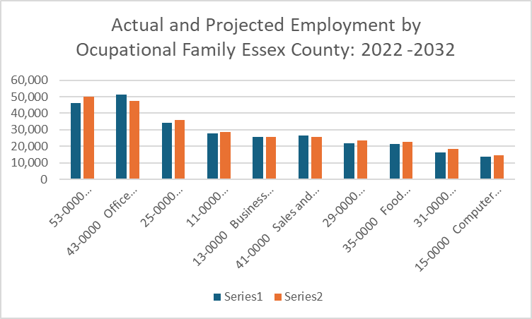

Policy Changes
Newly introduced FY26 WFNJ addendum regarding required employment targets, while conceivable as stretch objectives to enhance overall employability in the state, may potentially have deleterious effects on procurement processes. These policies may adversely impact the prospect of some of our population getting necessary training and creating talent pipelines for different industries.

