
PLAN MODIFICATION IN ADDENDUM
OCTOBER 2025

TABLE OF CONTENTS |  | Page
INTRODUCTION | Executive Summary | 3
SECTION I | REGIONAL AND LOCAL WORKFORCE STRATEGIES  - Analysis of Labor Market  - Strategic Priorities | 5
SECTION II | ONE-STOP CAREER CENTER OPERATIONS  - One-Stop Service Delivery and Flow  - Operational Priorities  - Service Expansion and Accessibility in One-Stop Career Centers  - Detailed Partnership and Service Integration  - Employer Engagement | 30
SECTION III | LOCAL WDB STRUCTURE AND FUNCTIONS  - Local Workforce Development Area Structure  - Procurement of Operator and Services  - Oversight and Monitoring  - Performance Measures and Accountability  - Training and Development  - Regional and Local Plan Development  - Additional Elements | 36
APPENDICES | - Flow and Service Provision Policy  - Priority of Service Policy  - One-Stop Partner MOU  - WDB Membership  - Code of Conduct/Conflict of Interest Policy  - Local Chief Elected Official & WDB MOU | 52

EXECUTIVE SUMMARY

The Workforce Innovation and Opportunity Act (WIOA) is a federal law that provides funding and support for workforce development programs across the United States. WIOA was signed into law in 2014, replacing the Workforce Investment Act of 1998.
WIOA is an essential piece of legislation that helps job seekers and workers succeed. The law provides funding and support for various workforce development programs and services, emphasizing equity, inclusion, partnerships, and performance accountability.
The legislation (WIOA) goes beyond encouraging Workforce Development Boards (WDB) to lead local economic development efforts for the Essex County Workforce development system. The legislation, the funding, and this “system” (workforce development) empower the development of programming that assists job seekers and workers in accessing the education, training, and support services residents need to succeed in the New Jersey economy.
The law also puts specific performance metrics in place and encourages the strengthening of partnerships between the public and private sector–to enhance and expand workforce development initiatives; these initiatives must increase employment opportunities with livable wages.
The “Act” (WIOA) further supports Essex County’s initiatives through programmatic funding for various workforce development programs found in this Essex County Workforce Development Board Strategic Plan. In addition to a high level of coordination with regional workforce and economic development entities, the funding provided by WIOA must address the following key areas:
- Adult Education and Family Literacy Programs
- Vocational Rehabilitation
- Youth Employment and Training Programs
- Dislocated Worker Programs
- Employment Services
The purpose of the Essex County WDB Strategic Plan is to guide the use of WIOA resources to develop or improve programs that uplift the economic conditions of the workforce in Essex County. This plan, developed under the guidance of the New Jersey State Employment and Training Commission (SETC) and regional entities (i.e., North Jersey Partners), will guide the activities of the Workforce Development Board.
WIOA requires WDBs and States to develop a “unified state plan” that describes how the State of New Jersey will use the provided WIOA funding to deliver effective and efficient workforce development programs and services to its residents. Local plans, like this one, are part of the State’s required compliance and bring together the development of a unified strategy between all its partners. Key elements of this legislation are:
- A focus on equity and inclusion: WIOA requires states to provide workforce development programs and services to all residents, regardless of race, ethnicity, gender, disability, or socioeconomic status.
- An emphasis on partnerships: WIOA requires states to work with employers, educational institutions, and other partners to develop and deliver workforce development programs and services.

- A focus on performance accountability: WIOA requires states to track and report on the performance of their workforce development programs.
About the Essex County Workforce Development Board

The Essex County Workforce Development Board covers a single economic area that leads and coordinates the workforce activities of the third largest county in New Jersey. The Essex County WDB is a Division under the County’s Department of Economic Development, Training, and Employment.

The WDB oversees programs and services under the Essex County Division of Training and Employment and the “Essex County One-Stop Career Center.” The authority over the development of the WDB activities resides with the “Chief Lead Elected Official” (CLEO) for Essex County–the Essex County Executive.
Essex County’s WDB administrative offices are 50 South Clinton Street, East Orange, NJ. Essex County (the county) is one (1) of twenty-one (21) counties in New Jersey and located in the northern part of the State, as part of the New York/New Jersey Metropolitan area; within it resides several significant cities that influence the economies of other New Jersey counties, cities and States. Besides Newark, the four most socio-economically active towns in Essex County are East Orange, Orange, and Irvington.

SECTION I:
Regional and Local Workforce Strategies

A. ANALYSIS OF THE LABOR MARKET
(The data in this section of the plan has been obtained from a variety of sources including the US Bureau of Labor Statistics, New Jersey Department of Labor and Workforce Development, MIT Living Wage Calculator and Regional Data Analysis.)

Essex County hosts a diverse economy with significant growth, signaling an upward trend and an increased demand for (and opportunities within) key industry sectors that align with the goals of the State of New Jersey.

The county is a central transportation hub, with Newark Liberty International Airport and the Port Newark-Elizabeth Marine Terminal within its borders. With the growth of online consumerism, we project that logistics and transportation will further develop to support the State’s Green Energy and Sustainability investments and Essex County’s focus on expanding the infrastructure for transport and logistics.

As per the 2020 Census, the county has an approximate population of 800,000 (803,117) residents, representing a 1.2% increase from 2010 and a slowed migration to Essex County between 2000 and 2010. As most of the work by the WDB will focus on the inclusion of diverse and underrepresented populations, it is vital to summarize the racial makeup of the county, which is:
- White (29.1 %)
- Black or African American (37.4%)
- Hispanic or Latino (18%)
- Asian (5.5%)
- Other (10 %)

ESSEX COUNTY DEMOGRAPHICS PER 2020 CENSUS
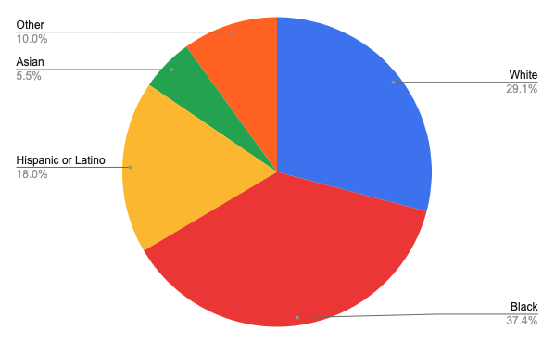

The median age in Essex County is 37.7 years old, with a median income of $63,959. This is an increase from $32,708– approximately a 51% increase in the median salary over the last ten years. When defining the poverty rate as the “minimum income needed to secure basic needs for food, clothing, and shelter – Essex County leads the State with 15.3% of its residents living in or at poverty levels. Poverty levels for the State currently are at 9.7%.

Whereas a significant percentage of the county’s population lives in poverty, the WDB is continuously working to improve coordination between initiatives and resources that encourage diversity, especially in the space of economic mobility for the majority of its population. At 55.4%, the majority of the population in Essex is African American and Hispanic/Latino.

As illustrated in the Labor Market Statistics provided by the New Jersey Department of Labor and Workforce Development, employment opportunities in Essex County slowly grew over ten years, taking a deep decline in the pandemic and almost wholly rebounded to pre-pandemic levels. The second chart shows how unemployment has followed a similar trend, a decrease in the ten years leading up to the pandemic and a recovery to almost pre-pandemic levels only two years after 2020.

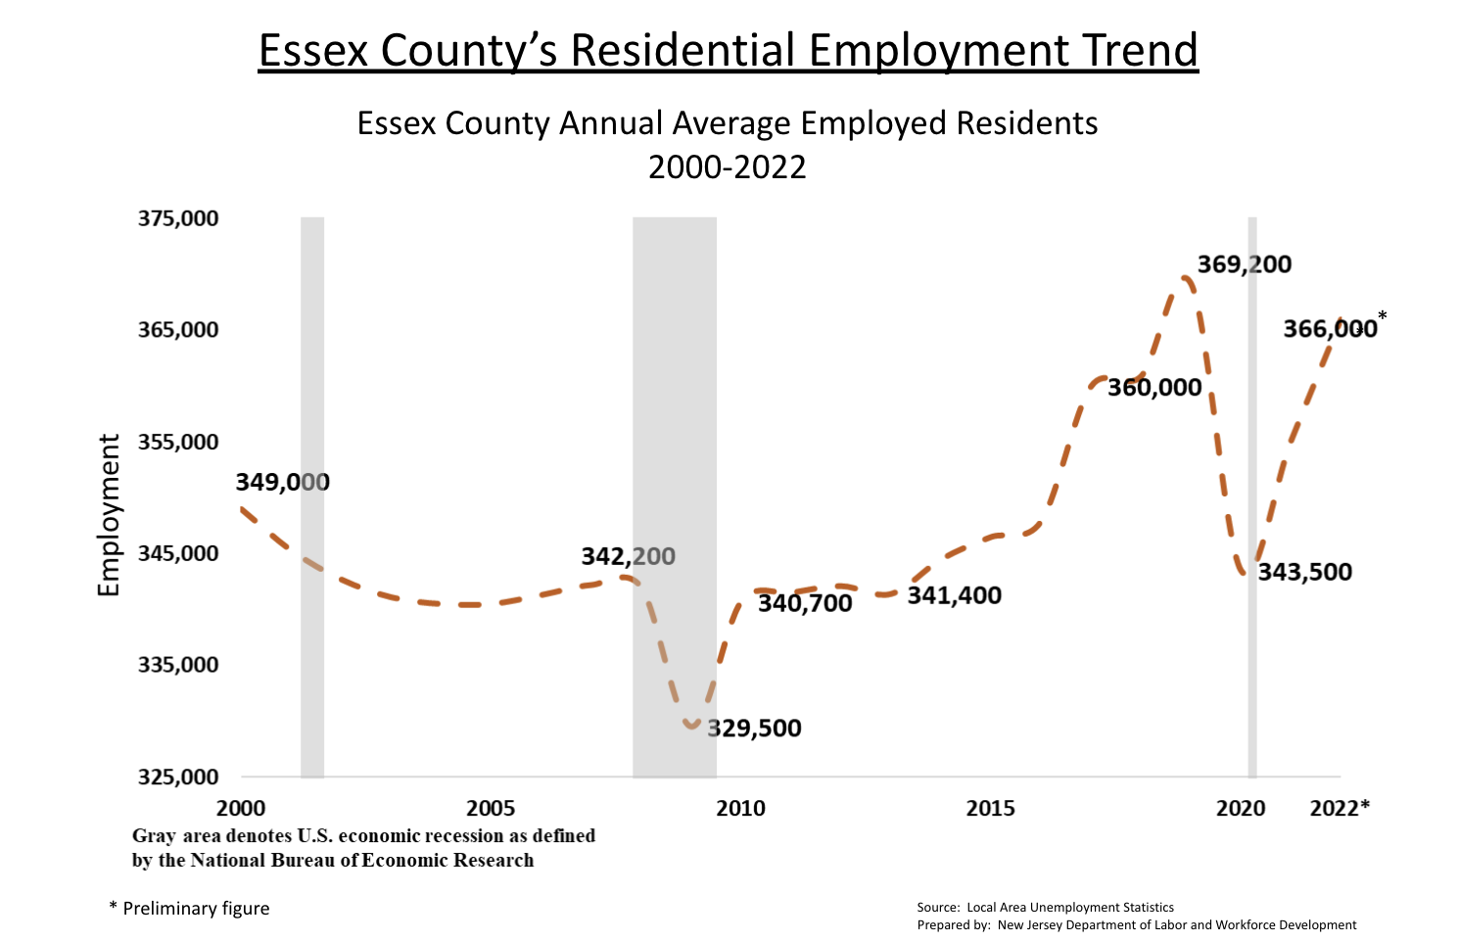

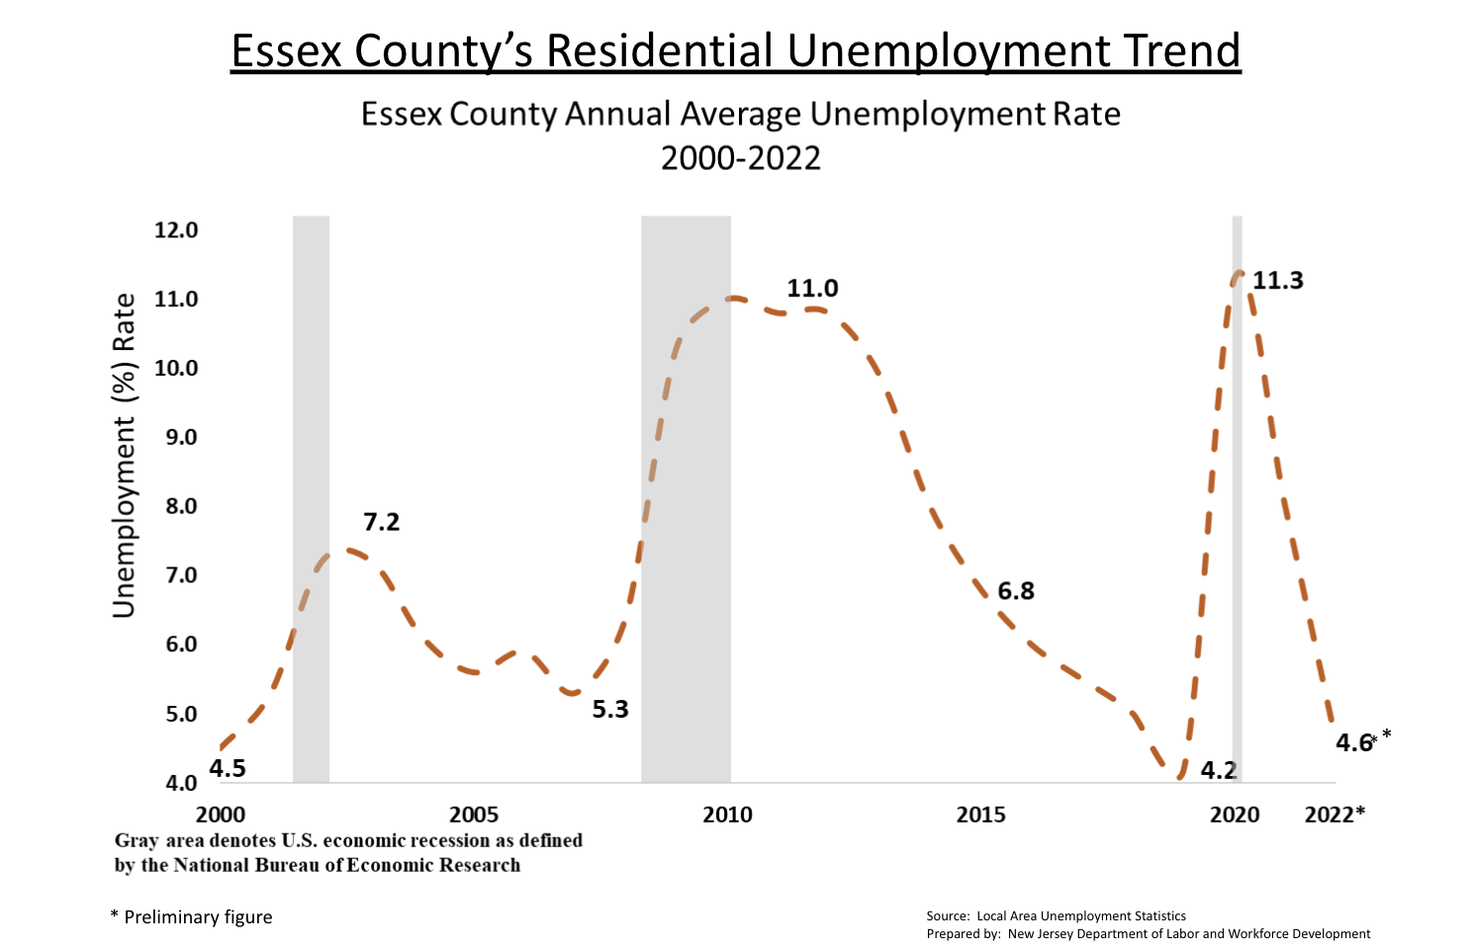

In short, the population of Essex County has yet to grow in size. The population of Essex County has remained stable in size, but there have been significant changes in its economic and racial makeup. Over 15% of the county's residents were born outside the United States, making immigrants a crucial part of the local economy.

As such, the WDB will include programming and strategic planning to support them, focusing on the recently arrived Haitian population. Although WIOA funding cannot provide direct services to immigrants without legal residence or citizenship, the WDB will keep track of their participation in the local economy for future planning.

For example, the Haitian population in East Orange and Irvington now totals 14,000. The WDB will convene a meeting to discuss how to provide services to this growing population., but it has changed in its racial and economic makeup and is home to a large immigrant population, with over 15% of the residents of Essex County being born outside of the United States.

Immigrants are a significant part of the local economy, so programming and strategic planning will include them. A particular focus is its recently arrived Haitian population. Whereas funding for WIOA services can not provide services directly to immigrants who do not have legal residence or citizenship, the WDB will keep track of this information as their participation in the local economy is a factor in future planning.

For example, the Haitian population in East Orange and Irvington now totals 14,000, and the WDB will be convening a meeting to discuss how services will be provided to this significant and growing population.

BREAKDOWN OF ESSEX COUNTY IMMIGRATION POPULATION
(BY COUNTRY OF ORIGIN)
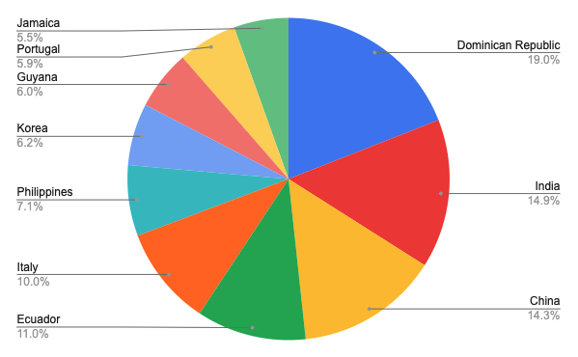

Local and Regional Economic Conditions
The regional economic conditions of Northern New Jersey are generally positive. The unemployment rate in Northern New Jersey is below the state and national averages, and the region has several major businesses and industries. However, some challenges are facing the Northern New Jersey economy, such as the high cost of living and the aging infrastructure. Businesses located in Essex County that invest in the economic development and infrastructure to conduct their business are:
- Service and Hospitality;
- Financial Services;
- Healthcare & Life Sciences;
- Education; and,
- Retail

Based on NJDLWD Labor market statistics, you will further see below that employment supports where the businesses of Essex County are growing and investing. The charts below show job growth in key industries in Essex County and further support that the highest job growth is in Finance/Insurance/Real Estate, Professional Services, and Education/Healthcare/Social Services. Job growth is illustrated in the Resident Employment and Employment by Industry Statistics below.

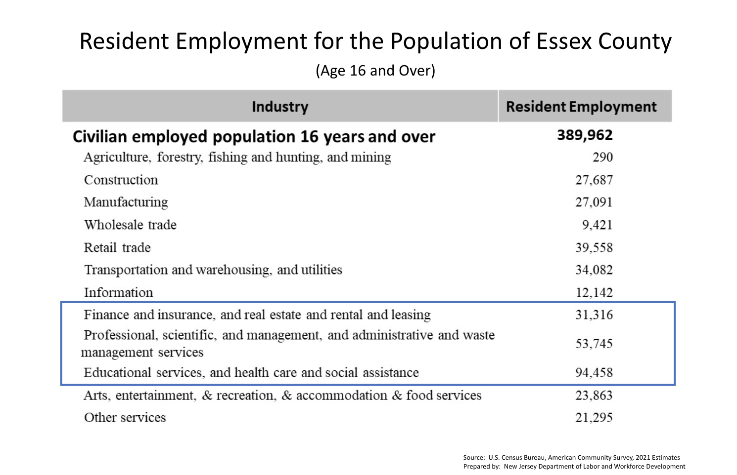
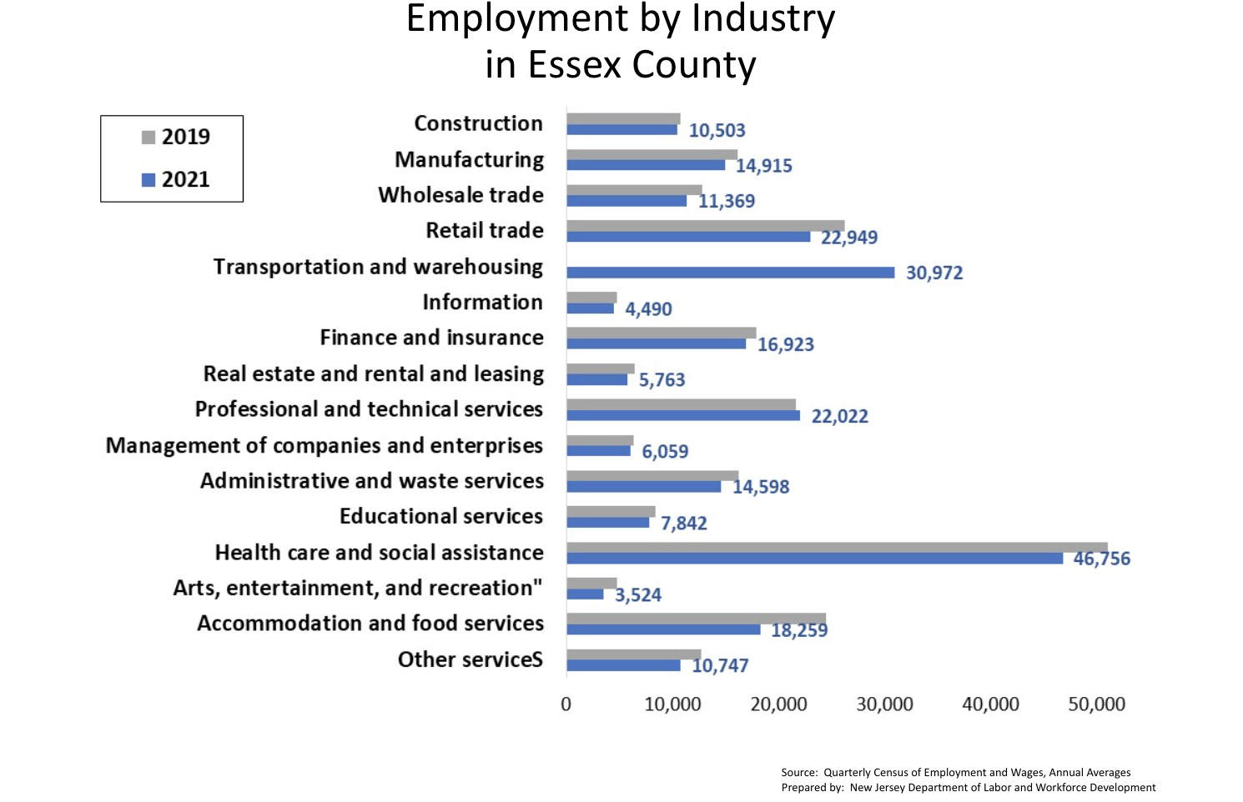

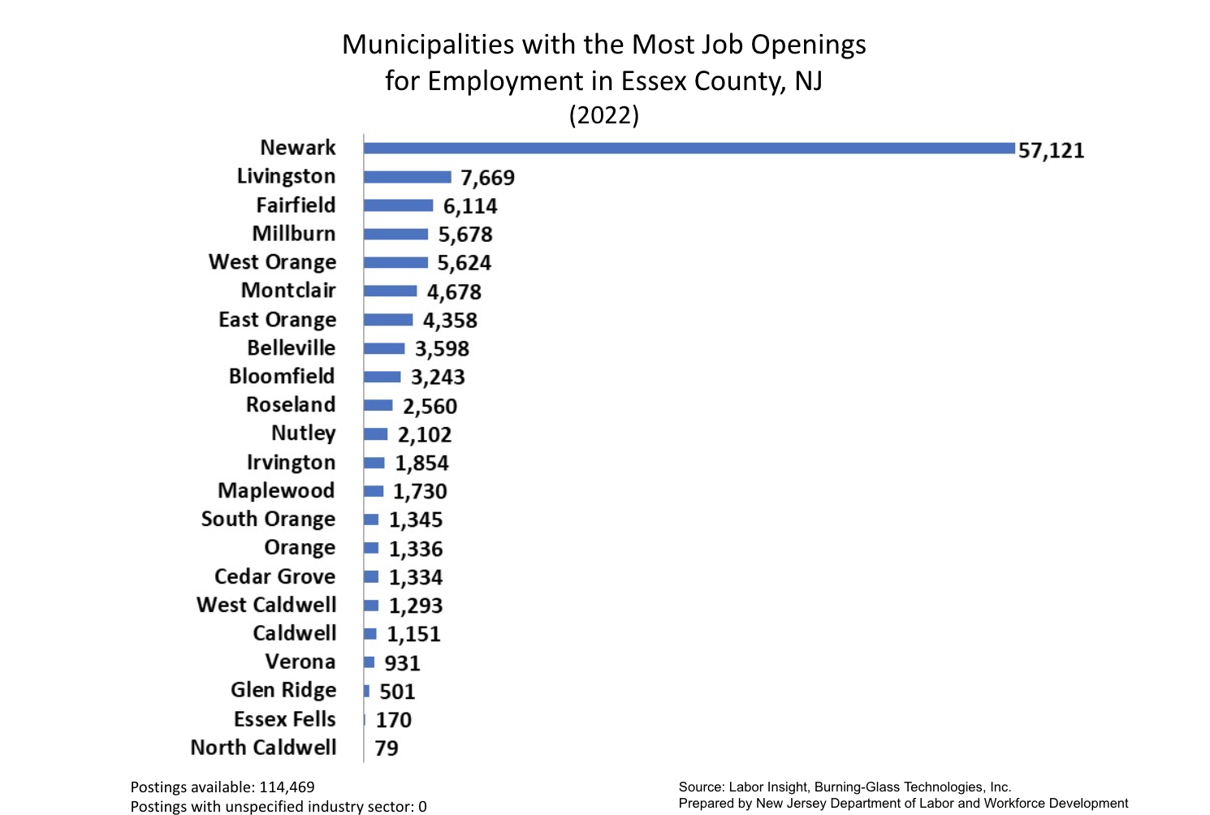

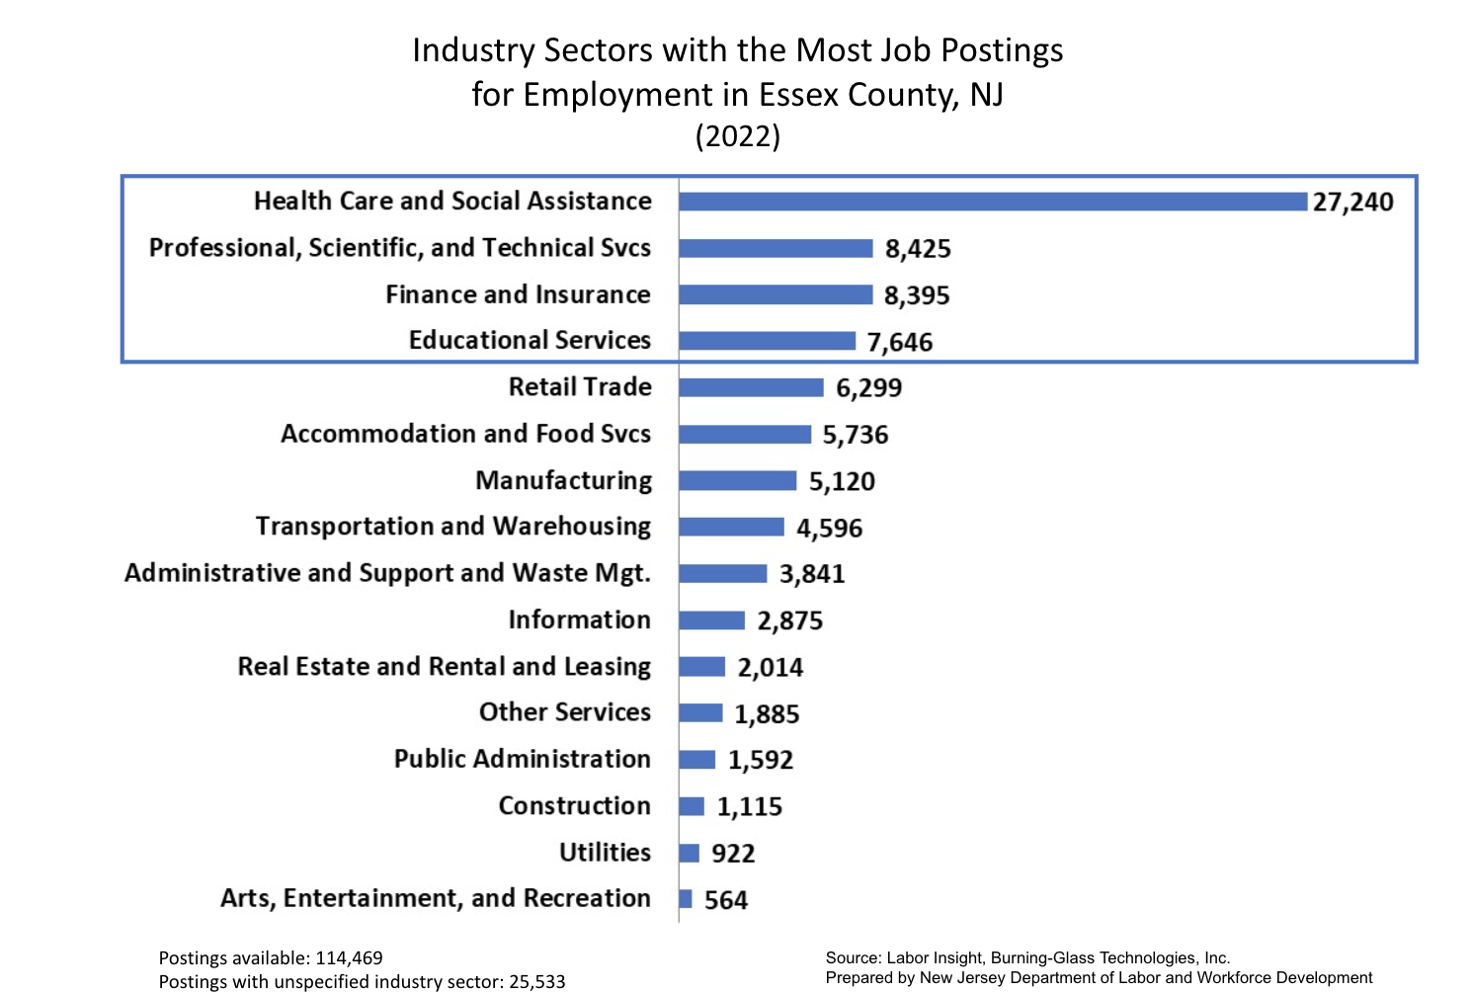

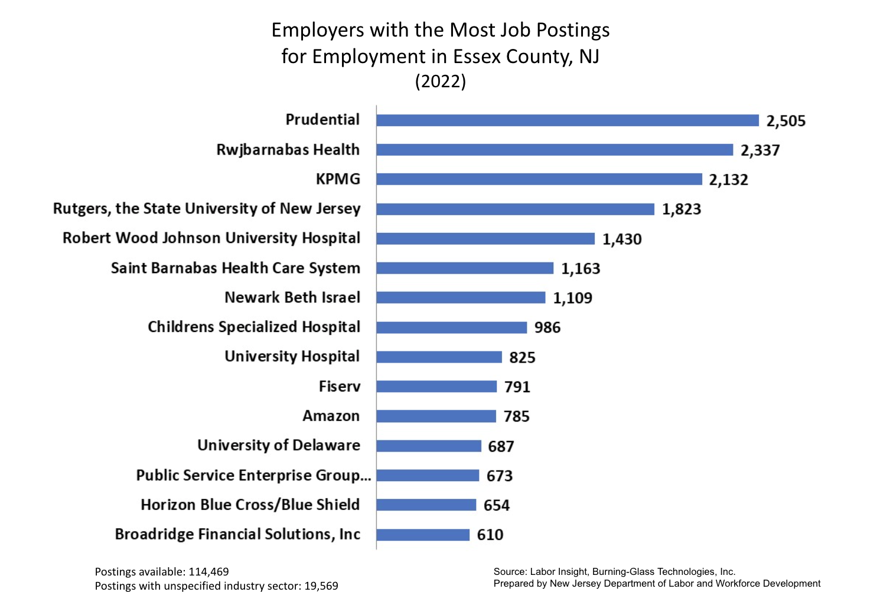
Economic Strengths
- Northern New Jersey is home to several major businesses and industries, including finance, healthcare, education, and technology.
- The region has a highly skilled workforce.
- Northern New Jersey is a major transportation hub, with Newark Liberty International Airport and Port Newark-Elizabeth Marine Terminal within its borders.
- The region is also home to many colleges and universities, which helps to attract and retain talent.
Economic Challenges
- The cost of living in Northern New Jersey is high, particularly in the New York City metropolitan area.
- The region's infrastructure is aging, and there are significant needs for investment in transportation and other infrastructure projects.
- The region is also facing demographic challenges, such as an aging population and a shrinking workforce.

Outlook for the Future
The region is expected to continue to grow in the coming years, driven by the growth of the finance, healthcare, and technology industries. However, the region will also need to address its challenges, such as the high cost of living and the aging infrastructure.

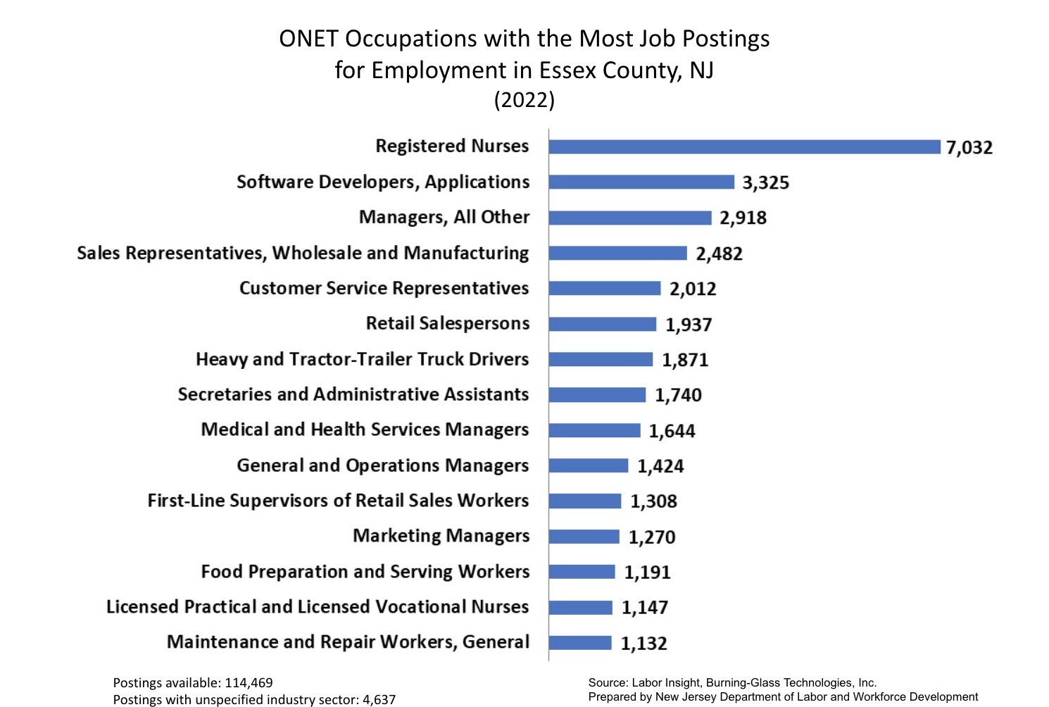

Policies to Support Economic Growth
There are some policies that can be implemented to support economic growth in Northern New Jersey. These include:
- Investing in education and training programs to develop workforce skills.
- Investing in infrastructure projects to improve transportation and other infrastructure in the region.
- Providing tax breaks and other incentives to attract and retain businesses.
- Promoting entrepreneurship and small business development in coordination with the Office of Small Business and Affirmative Action.
- Making the region more affordable for residents and businesses.
By implementing these policies, Northern New Jersey can continue to grow and thrive in the future.
Analysis Of Knowledge And Skills Needed To Meet Employment Needs Of Employers
The knowledge and skills needed to meet the employment needs of employers in New Jersey vary depending on the specific industry and occupation. However, there are several basic skills that all industry segments require:

- Communication skills: Employers are looking for employees who can communicate effectively, both verbally and in writing. This includes the ability to receive and impart clear instruction or direction; the ability to correspond and communicate with individuals both inside and outside of an organization, and be able to collaborate with others.
- Problem-solving/Critical Thinking Skills: Employers need employees who can think critically and solve problems effectively. This includes the ability to identify and analyze problems, develop and implement solutions, and learn from mistakes.
- Technological skills: Employers are increasingly looking for employees who have strong technological skills. This includes the ability to use computers and basic office software, as well as the interest and ability to learn new technologies quickly.
- Adaptability and flexibility: Employers need employees who are adaptable and flexible. This includes the willingness and ability to learn new things, the ability to adapt to change, and the ability to work independently and as part of a team.
By further comparing the Labor Market information of the NJDLWD the first chart below shows that the largest job growth is related to Customer Service, scheduling, and Sales. This further emphasizes the skills summarized above, which points to a future where adaptability and interpersonal skills are the most important–followed by areas of specialization. This can be further compared by the baseline skills chart and the programming Software skills that are in demand across most industries.
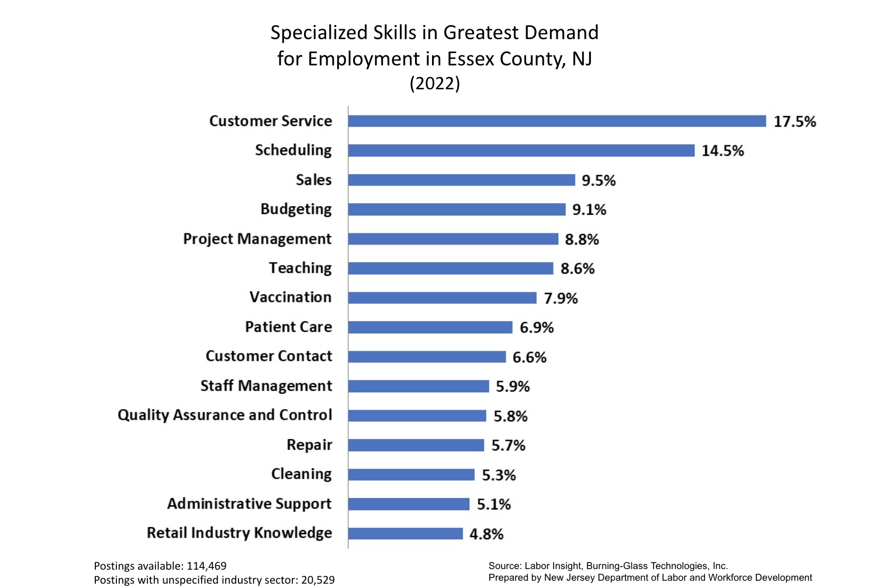

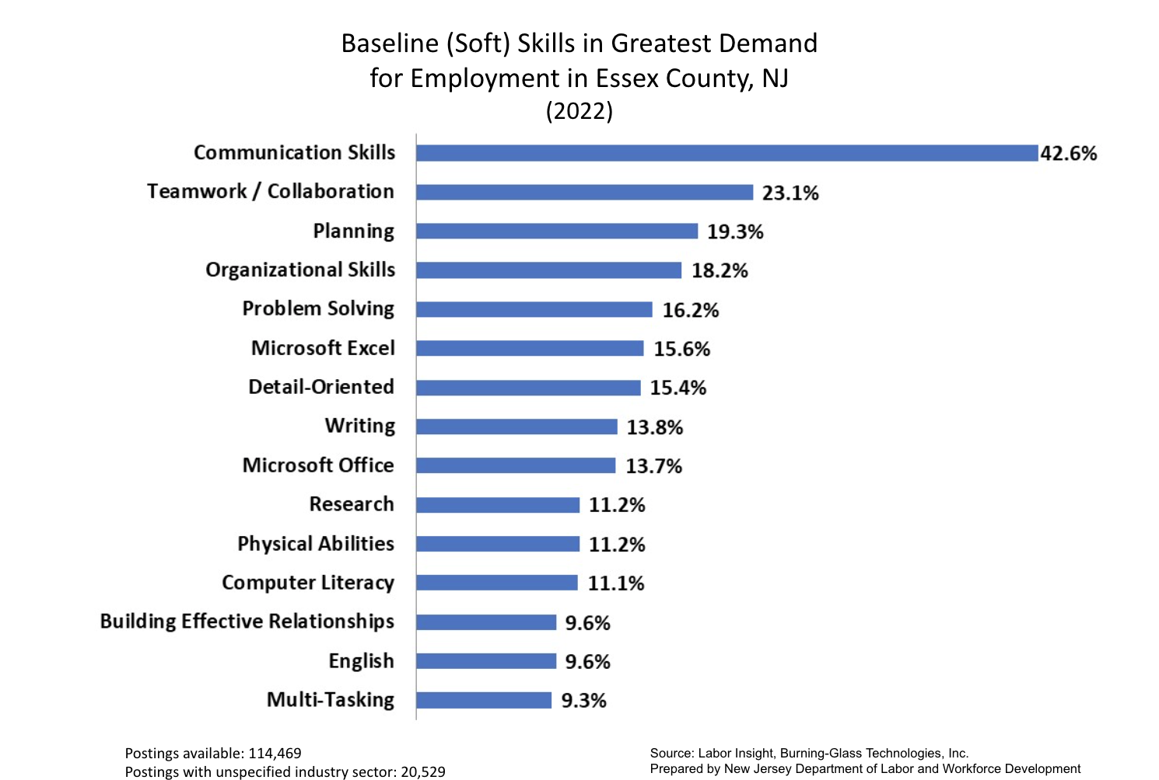

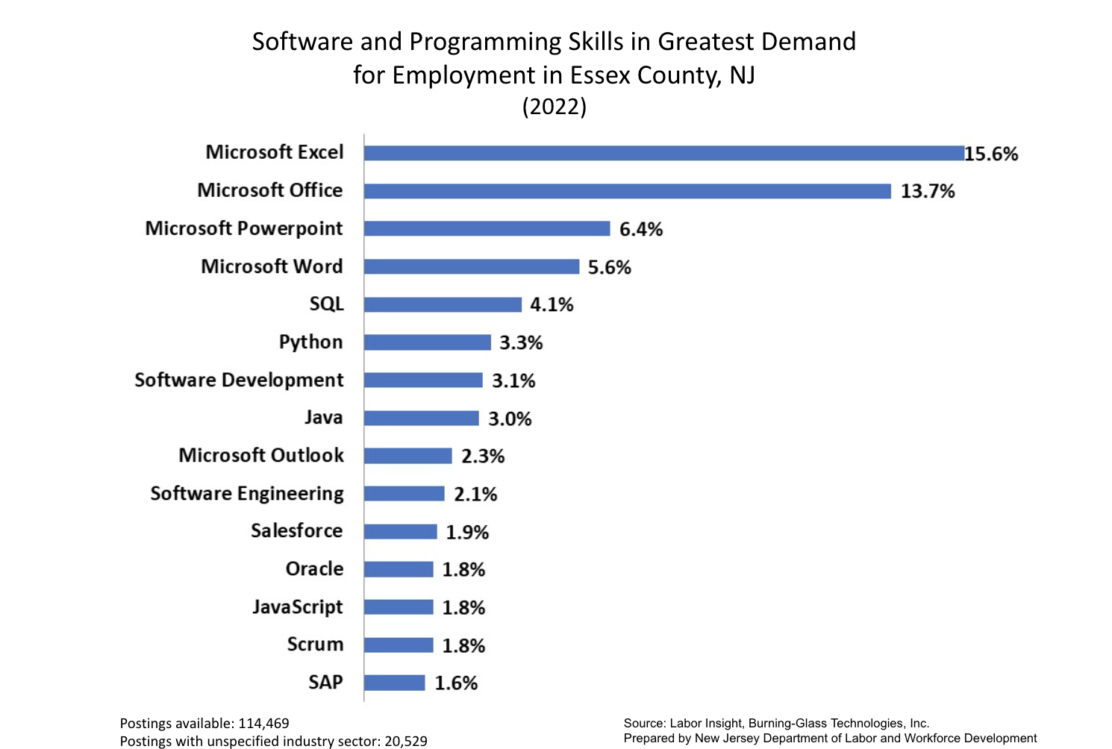

Further analysis of the labor market and industries that are positioned to grow in the next decade are outlined below and compared to the cost of living and economic opportunities available–as compared to the employment opportunities.
The following is a summary of the industries the Workforce Development Board finds are growing, further supporting NJDLWD Labor Market Information:
- Industry mix: The largest industries in Essex County are finance, healthcare, education, and retail. These industries employ a combined 50% of the workforce in the county.
- Occupational mix: The most common occupations in Essex County are office and administrative support occupations, sales and related occupations, and service occupations. These occupations employ a combined 60% of the workforce in the county.
- Educational attainment: Most workers in Essex County have at least a high school diploma or GED. Over 30% of workers in the county have a bachelor's degree or higher.
- Wage and salary: The median wage for workers in Essex County is $52,000 per year. This is higher than the state and national medians.
- Unemployment rate: The unemployment rate in Essex County is 5.5%. This is lower than the state and national averages.
In-Demand Industry Sectors & Employment Skill Needs

While the economic makeup of the county includes all major industries, several markets stand out in terms of their growth potential, and yet within these varied segments the need for employees who know how to work with and use technology and who understand, and exhibit communication and collaboration skills to improve the customer experience and deliver a quality product to customers. These markets are

- Service & Hospitality: The service and hospitality sector experiences high levels of turnover. The industry needs more skilled workers in all areas such as food preparation, hospitality management, and customer service.

- Financial Services: The financial sector occupations currently in demand are in the trading and broking of capital markets, equity and security analysts, investments and merchant banking services, research and advisory services like mergers and acquisitions, commodity trading, risk management in financial markets, and portfolio management. This industry also relies on skilled support staff who are effective communicators and are knowledgeable of and use industry technology and tools.
- Healthcare: In this post-pandemic era the need for qualified and skilled healthcare professionals remains high. In addition to professional healthcare personnel such as doctors, nurses, physician assistants, lab technicians, etc., the industry needs qualified and skilled support staff who possess basic communication and computer skills.

- Education: In this sector, there is still a need for qualified teaching professionals and paraprofessionals, administrators, guidance counselors, and support staff who can interact with parents, teachers, and administrators.

- Retail: This industry also experiences high rates of turnover and is therefore in need of employees who have a basic education and have an interest in customer services/relations, cashiers, sales associates, visual merchandisers, loss prevention officers, store managers, and a host of other support staff. Employees must demonstrate people, communication, and technological skills/abilities.

To meet employers' needs in New Jersey, workers need to have a combination of general and specific knowledge and basic computer skills. Workers can develop these skills through education, training, and on-the-job experience.
Challenges facing the Workforce
Despite the strengths of the workforce in Essex County, there are also some challenges facing the county. These challenges include:
- The high cost of living: The cost of living in Essex County is high, particularly in areas closest to the New York City metropolitan area. This can make it difficult for workers to afford to live in the county.
- The aging workforce: The workforce in Essex County is aging. This means that there will be fewer workers available in the coming years.
- The skills gap: There is a skills gap between the skills that workers have and the skills that employers need. This can make it difficult for employers to find qualified workers.
Policy Recommendations to Address These Challenges Facing the Workforce In Essex County
There are some policy recommendations that can be implemented to address the challenges facing the workforce in Essex County. These include:
- Investing in education and training: Essex County needs to invest in education and training programs to develop the skills of its workforce and prepare workers for future jobs. This includes investing in early childhood education, K-12 education, and post-secondary education.
- Making the county more affordable to live in: Essex County can make itself more affordable for residents and businesses by investing in affordable housing, public transportation, and other infrastructure.
- Addressing the skills gap: Essex County can address it by working with employers to identify their workforce needs and develop training programs to meet them. The county can also provide support to workers who are seeking to retrain or upskill.
By implementing these policy recommendations, Essex County can ensure that its workforce has the skills and knowledge needed to succeed in the future.
Analysis of Workforce Development Opportunities in Essex County

Workforce Development Activities

Essex County, New Jersey offers a variety of workforce development programs to help residents develop the skills and knowledge they need to succeed in the workplace. These programs are offered by various organizations, including the Essex County Workforce Development Board, community colleges, and non-profit organizations.
Here is a summary of some of the workforce development programs available in Essex County, New Jersey:
- Job training programs: These programs provide training in various skills, such as computer skills, medical skills, and construction skills. Some job training programs are offered by community colleges, while others are offered by non-profit organizations.
- Apprenticeship programs: Apprenticeship programs allow workers to learn a trade while earning a paycheck. Apprenticeship programs are available in various industries, including construction, healthcare, and manufacturing.
- Career counseling services: Career counseling services can help job seekers identify their skills and interests, and develop a career plan. Career counseling services are offered by various organizations, including community colleges, non-profit organizations, and the New Jersey Department of Labor and Workforce Development.
- Job placement services: Job placement services can help job seekers find jobs that match their skills and interests. Job placement services are offered by various organizations, including community colleges, non-profit organizations, and the New Jersey Department of Labor and Workforce Development.
In addition to these general workforce development programs, Essex County offers many programs specifically targeted to certain populations, such as veterans, youth, and people with disabilities.
The Essex County Workforce Development Board also offers programs to help people with disabilities find and keep jobs. For example, the board offers the Supported Employment Program, which provides job training and job placement services to people with disabilities.
Overall, Essex County offers a variety of workforce development programs to help residents develop the skills and knowledge they need to succeed in the workplace. These programs are offered by various organizations, and they are tailored to meet the needs of different populations.
Given what has been learned from emerging industry sectors and in-demand occupations, there is an opportunity for Essex County to develop further and strengthen its knowledge and skills programs to meet the employment needs of employers in New Jersey. Beginning with:

- Education: Education is one of the best ways to develop the knowledge and skills needed for a successful career. Many employers require workers to have a high school diploma or GED, and many employers also prefer workers to have a college degree.
- Training: Many training programs can help workers develop the skills they need for specific occupations. These training programs can be offered by community colleges, technical schools, and employers themselves.
- On-the-job experience: On-the-job experience is another great way to develop the skills needed for a successful career. Many employers offer training programs to their new hires, and workers can also learn new skills by observing their colleagues and asking for feedback.

By developing the knowledge and skills needed to meet the employment needs of employers in New Jersey, workers can increase their chances of finding and keeping a good job.
The Impact of COVID-19 on Essex County Workforce
The COVID-19 pandemic has profoundly affected the workforce in Essex County, New Jersey. When the pandemic began, many businesses were forced to shut down or operate at reduced capacity, which caused widespread layoffs and furloughs. As a result, the unemployment rate in Essex County peaked at 20% in April 2020. Although the unemployment rate has decreased since then, it is still higher than before the pandemic. As of August 2023, the unemployment rate in Essex County stands at 4.5%, compared to 3.6% statewide.
he pandemic has disproportionately impacted certain sectors of the economy in Essex County. For example, the pandemic severely affected the leisure and hospitality industry, including restaurants, hotels, and entertainment venues. Many businesses in this sector had to shut down temporarily or permanently, and many workers lost their jobs. However, the healthcare industry grew during the pandemic. Nevertheless, healthcare workers have faced significant challenges, including increased workloads, exposure to the virus, and a shortage of personal protective equipment. Apart from the economic impact, the pandemic has also significantly affected the mental and physical health of workers in Essex County. Many workers have experienced anxiety, stress, and depression as a result of the pandemic. Furthermore, some workers have contracted COVID-19, which has led to serious health issues and even death.
Despite the challenges, the workforce in Essex County is slowly recovering from the pandemic. Businesses are reopening, and they are hiring new workers. The pandemic has shifted how people work, with many businesses implementing remote work arrangements. Additionally, there has been a high demand for workers in certain sectors, such as healthcare and logistics. However, some workers have decided to leave the workforce entirely due to concerns about their health and safety. Moreover, there is a growing skills gap, as some workers lack the necessary skills to thrive in the changing economy.
All in all, the COVID-19 pandemic has significantly impacted the workforce in Essex County, causing job losses, business closures, and changes in how people work. It is crucial to keep track of the pandemic's impact on the workforce and develop policies and programs supporting workers and businesses.

Workforce Development Programs in Essex County
There are a few different ways to find workforce development programs in Essex County, New Jersey. One way is to search online. The Essex County Workforce Development Board has a website that lists all of the workforce development programs available in the county. You can also search for workforce development programs on the websites of community colleges and non-profit organizations in the county.
Another way to find workforce development programs in Essex County, New Jersey is to contact the Essex County Workforce Development Board. The board can provide you with information about the programs available in the county and can help you find a program that is right for you.
You can also contact your local community college or non-profit organization to learn about their workforce development programs.
B. STRATEGIC PRIORITIES
The Essex County Strategic Vision for the Workforce Development Board is to be a leader in workforce development, with a highly skilled and adaptable workforce that meets the needs of employers and attracts new businesses to the county.
The Workforce Development Board's vision is based on the following four pillars:
- Alignment: The Workforce Development Board will align its programs and services with the needs of employers and the goals of the county's economic development plan.
- Access: The Workforce Development Board will ensure that all residents have access to the education, training, and support services they need to succeed in the workplace.
- Innovation: The Workforce Development Board will be innovative in its approach to workforce development, and will develop and implement new programs and services to meet the changing needs of the workforce.
- Accountability: The Workforce Development Board will be accountable for the results of its programs and services, and will track and report on its progress towards achieving its goals.
The Workforce Development Board is committed to working with employers, educational institutions, and other partners to achieve its vision. The board believes that a skilled and adaptable workforce is essential to the economic prosperity of Essex County.
The Workforce Development Board's vision is ambitious, but it is achievable. The board has the support of the county government, employers, and educational institutions. With this support, the board can make Essex County a leader in workforce development.
Here are some specific actions that the Workforce Development Board is taking to achieve its vision:
- Developing a workforce development plan aligned with the needs of employers and the goals of the county's economic development plan.
- Expanding access to workforce development programs and services by partnering with community colleges, non-profit organizations, and employers.
- Developing new and innovative workforce development programs and services, such as apprenticeships and online training programs.
- Track and report on the progress of workforce development programs and services to ensure they meet their goals.
The Workforce Development Board is committed to making Essex County a place where everyone can succeed in the workforce.
Core Program Strategies

New Jersey’s workforce is diverse. Different population groups often face varying challenges and barriers and may need more specific or dedicated services to meet their employment and training needs. There are many programs and services that address the needs of individuals with barriers to employment. Additionally, measures are being taken at the state and local levels to improve further programmatic and physical accessibility for LEP individuals and individuals with disabilities and improve overall education and employment outcomes for all individuals, especially individuals with significant barriers to employment. All core and required partners that provide services in the Essex County Workforce Development Area are part of the local workforce system. Essex County Division of Training and Employment administers a wide range of Work First New Jersey (WFNJ) activities focused on Temporary Assistance for Needy Families, General Assistance, and Able Body Adult Without Dependent clients. The division provides essential services and opportunities to clients to form a coordinated One-Stop System with support from the Division of Welfare, and the New Jersey Department of Labor and Workforce Development. Activities of the Essex County Division of Employment and Training include:

- Assessment and Training Referrals
- Job Search
- Job Readiness Preparation
- Administers Community Work Experience Program
- Supported Assistance to Individuals and Families
- Adult Basic Education Services
- Transportation Assistance to Clients
- Job Placement Assistance
- Career Resource Center
- GED Testing Center
- Program for Parents
The Essex County Department of Housing and Community Development offers housing development assistance and community development block grant opportunities to qualified organizations in various towns and municipalities, First Time Homebuyer Program, and Home Improvement Program. The Essex County Department of Citizen Services includes the Division of Family Assistance Benefits, Division of Senior Services, Division of Community Action, Human Services Advisory Council, Youth Services, and Mobile Citizens Services Office.
SECTION II:
One Stop Career Center Operations

A. ONE-STOP SERVICE DELIVERY AND FLOW

One-stop delivery and flow is a system of providing various services to customers at a single location. This can be done in a physical location, such as a brick-and-mortar store or government office, or it can be done online. One-stop delivery and flow aim to make it easier for customers to get the services they need, without having to go to different places.
Here is an example of a one-stop delivery and flow system for a job seeker:
- The job seeker goes to the one-stop center and meets with a career counselor.
- The career counselor helps the job seeker to assess their skills and interests and to develop a job search plan.
- The job seeker can use the one-stop center's resources to find job openings, write resumes and cover letters, and practice interviewing skills.
- The job seeker can also get help from the one-stop center to register for unemployment benefits.
In this example, the job seeker is able to get all of the services they need to find a job at a single location. This saves them time and hassle, making it more likely that they will succeed in their job search.
One-stop delivery and flow systems can be used to provide a variety of services, such as:
- Employment services
- Education and training services
- Social services
- Government services
One-stop delivery and flow systems can be beneficial for both customers and service providers. For customers, one-stop delivery and flow systems can make getting the services they need easier, saving them time and hassle. For service providers, one-stop delivery and flow systems can improve coordination and efficiency.
The benefits of one-stop delivery and flow are:
- Convenience for customers: Customers can get all the services they need at a single location, saving them time and hassle.
- Improved efficiency: One-stop delivery and flow systems can improve coordination and efficiency among service providers. This can lead to better outcomes for customers.
- Reduced costs: One-stop delivery and flow systems can help reduce costs for customers and service providers.
- Increased access to services: One-stop delivery and flow systems can make it easier for people to access the services they need, especially those who are underserved or who face barriers to accessing services.
One-stop delivery and flow systems are becoming increasingly common in various settings. As more and more organizations adopt one-stop delivery and flow systems, customers can expect to see even more convenience, efficiency, and access to services.
B. OPERATIONAL PRIORITIES

The operational priorities for a one-stop center are to provide convenient, efficient, and accessible services to customers. This can be achieved by focusing on the following areas:
- Customer experience: The customer experience should be at the center of all operational decisions. This means understanding the needs of customers and designing services around those needs. It also means making it easy for customers to access services and get the help they need when they need it.
- Coordination and collaboration: One-stop centers typically deliver services from various organizations. It is important to coordinate and collaborate with these organizations to ensure that services are delivered in a seamless and efficient manner. This may involve developing shared protocols, training staff on how to work together, and using technology to integrate systems.
- Efficiency and effectiveness: One-stop centers should strive to deliver services in an efficient and effective manner. This means using resources wisely, eliminating duplication of effort, and using technology to streamline processes. It also means measuring performance and making continuous improvements.
- Data and analytics: Data and analytics can improve the operational efficiency and effectiveness of one-stop centers. For example, data can be used to identify areas where there is duplication of effort, to identify areas where services can be improved, and to track customer satisfaction.
- Continuous improvement: One-stop centers should continuously strive to improve their operations. This can be done by collecting feedback from customers and staff, benchmarking against other organizations, and using data and analytics to identify areas for improvement.
By focusing on these operational priorities, one-stop centers can provide a positive customer experience and deliver high-quality services in an efficient and effective manner.
The Operational Priorities for a One-Stop Center are to:
- Make it easy for customers to find the services they need. This can be done by providing a clear and concise directory of services, having staff available to answer questions and provide assistance, and using technology to make it easy for customers to navigate the center.
- Reduce wait times for customers. This can be done by scheduling appointments in advance, streamlining processes, and cross-training staff to provide various services.
- Provide high-quality customer service. This means being friendly, helpful, and knowledgeable. It also means responding to customer needs and resolving issues quickly and efficiently.
- Use technology to improve the efficiency and effectiveness of operations. For example, technology can be used to automate tasks, to integrate systems, and to collect and analyze data.
- Continuously monitor and improve performance. This can be done by collecting feedback from customers and staff, by benchmarking against other organizations, and by using data and analytics to identify areas for improvement.
By focusing on these operational priorities, one-stop centers can provide a valuable service to their communities.
C. SERVICE EXPANSION AND ACCESSIBILITY IN ONE-STOP CAREER CENTERS

There are several ways to expand service and accessibility at one-stop centers:
- Expand the range of services offered. One-stop centers can offer various services, from employment and education services to social and government services. One-stop centers can become a more comprehensive customer resource by expanding the range of services offered.
- Extend the hours of operation. Many one-stop centers only operate during regular business hours. This can be a barrier for customers who work full-time or who have other commitments. By extending the hours of operation, one-stop centers can make it easier for customers to access the needed services.
- Increase the number of locations. One-stop centers are often located in major urban areas. This can make it difficult for people living in rural areas or underserved communities to access services. Increasing the number of locations allows one-stop centers to make their services more accessible to everyone.
- Provide remote services. One-stop centers can also provide remote services, such as online and phone-based services. This can make it easier for customers to access services from their homes or workplaces.
- Partner with other organizations. One-stop centers can partner with other organizations, such as community organizations, faith-based organizations, and businesses. This can help to expand the range of services offered and to make services more accessible to customers.
- Use technology to improve accessibility. Technology can be used to improve accessibility in some ways. For example, one-stop centers can use technology to provide translation services, and real-time captioning, and make their websites and other resources accessible to people with disabilities.
- I am developing a new MOU to explore and deliver services differently, using technology and existing resources.
Specific examples of initiatives that one-stop centers can implement to expand service and accessibility:
- Offer evening and weekend hours.
- Open satellite locations in underserved communities.
- Provide online and phone-based services.
- Partner with local businesses and community organizations to offer additional services.
- Provide translation and interpretation services.
- Make websites and other resources accessible to people with disabilities.
- Cross-train staff to provide a variety of services.
- Use technology to streamline processes and reduce wait times.
- Collect feedback from customers and staff to identify areas for improvement.
By implementing these initiatives, one-stop centers can become more comprehensive and accessible resources for their communities.
Workforce development boards (WDBs) and employers have a number of opportunities to partner and integrate services. Here are some examples:
- Joint training and apprenticeship programs. WDBs and employers can partner to develop and deliver joint training and apprenticeship programs. This can help employers to develop a pipeline of skilled workers, and can help job seekers to develop the skills they need to get good jobs.
- Job placement services. WDBs can help employers to find and hire qualified workers. Job fairs, online job boards, and other job placement services can do this.
- On-the-job training. WDBs can provide financial assistance to employers who offer on-the-job training to their employees. This can help employers train new employees and upgrade their existing employees' skills.
- Career counseling and support services. WDBs can provide career counseling and support services to employees of partner employers. This can help employees develop their careers and advance within their organizations.
- Data and analytics. WDBs can share data and analytics with partner employers to help them to identify workforce trends and to make informed decisions about their workforce needs.
- Advocacy. WDBs can advocate for policies and programs that support employers and workers. This could include advocating for funding for workforce development programs, for tax breaks for businesses that invest in training their employees, and for other policies that promote economic growth and job creation.
D. DETAILED PARTNERSHIP AND SERVICE INTEGRATIONS
Here are some specific examples of partnership and service integrations between WDBs and employers:
- A WDB and a local manufacturing company partner to develop a customized training program for new employees. The WDB provides funding for the training program, and the manufacturing company provides the training facilities and instructors.
- A WDB and a local hospital partner to offer job placement services to hospital employees facing layoffs. The WDB provides resume writing assistance, interview coaching, and other job search assistance to hospital employees.
- A WDB and a local construction company partner to offer on-the-job training to new construction workers. The WDB provides financial assistance to the construction company to cover the costs of the training program.
- A WDB and a local technology company partner to provide career counseling and support services to the company's employees. The WDB provides career counselors who offer employees individual and group counseling sessions.
- A WDB and a local chambers of commerce partner to share data and analytics on workforce trends. The WDB provides the Chamber of Commerce with data on the skills and qualifications of the local workforce. The chamber of commerce shares this data with its member businesses to help them make informed decisions about their workforce needs.
- A WDB and the Employer Association of New Jersey advocate for policies and programs that support employers and workers. The WDB and the employer association work together to educate policymakers about workforce development's importance and advocate for funding for workforce development programs.
These are just a few examples of how WDBs and employers can partner and integrate services. By working together, WDBs and employers can improve the outcomes for job seekers and employers alike.
E. EMPLOYER ENGAGEMENT
A workforce development board (WDB) can increase employer engagement in several ways. Here are a few ideas:
- Build relationships with employers. WDB members should try to get to know employers in their communities and understand their needs. This can be done by attending industry events, meeting with individual employers, and participating in joint initiatives.
- Develop programs and services that meet the needs of employers. WDBs should work with employers to identify their workforce needs and to develop programs and services that address those needs. This could include training programs, apprenticeship programs, and job placement services.
- Make it easy for employers to get involved. WDBs should make it easy for employers to get involved in their activities. This could involve providing online resources, offering flexible meeting times, and providing support to employers who are new to working with WDBs.
- Promote the benefits of working with WDBs. WDBs should promote the benefits of working with them to employers. This could include highlighting the cost savings that employers can achieve by working with WDBs, the access to qualified workers that WDBs can provide, and the opportunity to participate in innovative workforce development programs.
- Recognize and reward employers who engage with WDBs. WDBs should recognize and reward employers who engage with them. This could be done through public recognition, awards, or other incentives.
Here are some specific examples of initiatives that WDBs can implement to increase employer engagement:
- Create an employer advisory council. An employer advisory council can provide WDBs with input on their programs and services and help promote WDBs to other employers.
- Host employer events. WDBs can host events for employers to learn about their programs and services, and to network with other employers.
- Offer customized training programs. WDBs can work with employers to develop customized training programs that meet their needs.
- Provide job placement services. WDBs can help employers to find and hire qualified workers.
- Provide financial incentives to employers who hire WDB participants. WDBs can provide financial incentives to employers who hire WDB participants, such as on-the-job training reimbursements or tax credits.
By implementing these initiatives, WDBs can increase employer engagement and improve the outcomes for job seekers and employers.
SECTION III:
LOCAL WDB STRUCTURE & FUNCTIONS
A. Local Workforce Development Area Structure
The Essex County Workforce Development System is a network of organizations that collaborate to provide workforce development programs and services to residents of Essex County, New Jersey. The system is led by the Essex County Workforce Development Board, a public-private partnership that includes representatives from employers, educational institutions, and government agencies.

The board consists of 25 members, of which 13 are business owners and the economic development director. Six members represent organized labor and community-based organizations, two representatives from Education, two government partners, and two Private Vocational School Directors.
The One-Stop Operator is housed in the Essex County Department of Employment & Training, and the Division Director of that department currently fulfills the direct services provided by the “One Stop.” This arrangement allows for the separation of direct services and the oversight role fulfilled by the Workforce Development Board. Units under this Department and Division shall also include 1) Monitoring, 2) Outreach, 3) MIs, and 4) Contracting.
This is the plan of the Essex County Department of Employment and Training to implement a separation of duties by creating a new division within the department for the WDB.
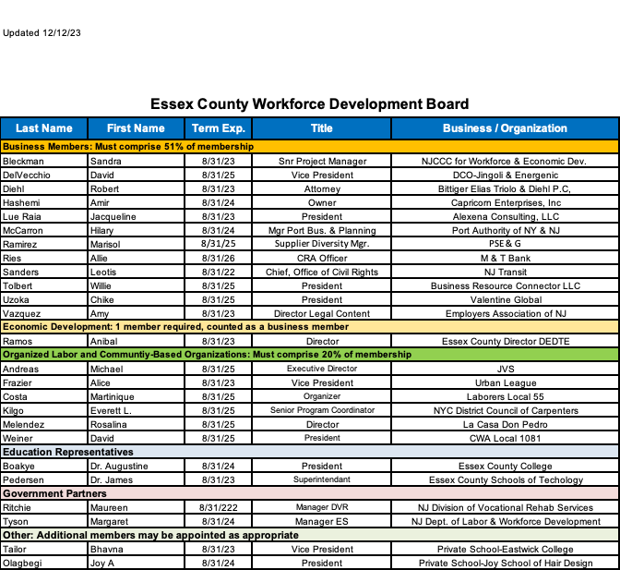
The Essex County Workforce Development System offers a wide range of programs and services to job seekers and workers, including:
- Job training programs: The system offers job training programs in a variety of occupations, including healthcare, construction, and manufacturing. These programs are typically offered by community colleges and non-profit organizations.
- Apprenticeship programs: The system offers apprenticeship programs in a variety of trades, such as plumbing, electrical work, and carpentry. Apprenticeship programs allow workers to learn a trade while earning a paycheck.
- Career counseling services: The system offers career counseling services to help job seekers identify their skills and interests, and develop a career plan. Career counseling services are offered by the Division of Training and Employment.
- Job placement services: The system offers job placement services to help job seekers find jobs that match their skills and interests. Job placement services are typically offered by community colleges and non-profit organizations.
In addition to these general workforce development programs and services, the Essex County Workforce Development System also offers a number of programs that are specifically targeted to certain populations, such as veterans, youth, and people with disabilities.
The Essex County Workforce Development System is committed to helping all residents of Essex County develop the skills and knowledge they need to succeed in the workplace. The system offers a wide range of programs and services to meet the needs of job seekers and workers of all ages, backgrounds, and abilities.
How to access the Essex County Workforce Development System
There are a few different ways to access the Essex County Workforce Development System. One way is to contact the Essex County Workforce Development Board. The board can provide information about the programs and services available in the county and help you find a program that is right for you.
You can also contact your local community college or non-profit organization to learn about their workforce development programs and services.
Finally, you can search for workforce development programs and services online. The Essex County Workforce Development Board's website lists all of the workforce development programs available in the county. You can also search for workforce development programs on the county's websites of community colleges and non-profit organizations.
The Essex County Workforce Development System is here to help you succeed in the workforce. Please contact the system today to learn more about the programs and services available to you.
B. Procurement of Operator and Services
Consistent with section 121(d) of the Workforce Innovation and Opportunity Act, the Essex County Workforce Development Board, with the agreement of the Chief Elected Officials shall designate or certify one-stop operators and may terminate for the cause the eligibility of the provider selected.
Selection of the One-Stop Operator will be through a competitive process and shall be a public, private, nonprofit, or consortium of entities composed of three (3) or more American One-Stop Career Center Partners. The selected One-Stop Operator will have demonstrated effectiveness and will be located in the local area. Examples of organizations that may competitively apply include Institutions of higher education, employment service State Wagner-Peyser Act agencies, community-based organizations, nonprofit organizations, private-for-profit organizations, labor organizations, career and technical education schools, and other interested organizations, career and technical education schools, and other interested organizations and entities. Elementary and secondary schools shall not be eligible for designation or certification as a One-Stop Operator.
Organizations applying for One-Stop Operator designation must disclose any potential conflicts of interest arising from the relationships with other service providers. The selected One-Stop Operator(s) may not establish practices that create disincentives to providing services to individuals with barriers to employment who may require longer-term services, such as intensive employment, training, and education services. And, the selected One-Stop Operator(s) must comply with Federal regulations and procurement policies related to calculating and using profits.
The One-Stop Operator must coordinate the service delivery of required one-stop partners, service providers of core program patterns, and other required partners working with the One-Stop Centers. This includes managing partner responsibilities in the One-Stop as defined in the Memorandum of Understanding (MOU). In support of the WIOA MOU the One-Stop Operator's responsibilities will specifically include:
- Coordinating service delivery among partners
- Managing hours of operation at the One-Stop Centers
- Facilitating customer flow, customer service, initial assessment, resource room usage, tracking, and referral processes are carried out as agreed to in the WIOA MOU.
Communicating Board and Administrative policies and procedures to all partners
- Reporting to the Administration and Board on Center activities

The One-Stop Operator will submit a written and verbal report on work accomplished and challenges encountered quarterly to the Essex County WDB. In addition, the One-Stop Operator will gather data from the Board from the partners quarterly including common measure information; tracking incoming clients; resource room usage; and program-specific referrals as outlined in the WIOA MOU.

The budget for the One-Stop Operator will be negotiated during the competitive procurement award process.

To ensure no conflict of interest or perceived conflict of interest, the Essex County WDB contracts with an independent consultant to facilitate the procurement process. The independent contractor will develop the request for proposal (RFP) and evaluation tool. No workforce system or potential service provider will be involved in developing the RFP or the selection process. Upon thorough evaluation, the contractor will recommend one proposal from the RFP submissions, and propose the selection recommendation to a special committee of the Essex County WDB to review. The committee’s recommendation will then be sent to the full board for approval.

The Board approved contractor and the special committee’s recommendation will then be sent to the purchasing department for implementation.
C. Oversight and Monitoring
Bylaws play a critical role in supporting oversight and monitoring by establishing a clear framework for governance and accountability. In Essex County, they achieve this in different ways. Essex County’s Bylaws support the WIOA legislation and provide the framework to “develop and coordinate the implementation of a four-year comprehensive local workforce development plan that identifies needs, goals, strategies, and policies for the local workforce development area. A local workforce development plan shall be updated every two years and revised as necessary. A local workforce development board shall coordinate the convening of local workforce development system stakeholders to assist in developing the local workforce development plan.”

- Defining roles and responsibilities: Bylaws clearly outline the roles and responsibilities of different stakeholders, including board members, officers, committees, and staff. This helps to ensure that there is no ambiguity about who is responsible for various tasks and decisions, and it facilitates the efficient oversight and monitoring of the system.
Excerpt from Essex County WDB Bylaws: “Develop and coordinate the alignment of the local area's workforce development programs, services, and activities in an integrated and streamlined workforce development system that is data-driven and responsive to the needs of workers, job seekers, and employers.”

- Establishing rules and procedures: Bylaws establish clear rules and procedures for decision-making, financial management, communication, and other important functions. This helps to ensure that all activities are conducted in a transparent and consistent manner, and it provides a basis for monitoring compliance with these rules.
Excerpt from Essex County WDB Bylaws: “Develop and coordinate policies that increase access to workforce services for all New Jerseyans, particularly for individuals with a barrier to employment as defined in the federal Workforce Innovation and Opportunity Act, Pub. L. No. 113-128, section 3(24).”

- Promoting transparency and accountability: Bylaws require disclosing information about the organization's activities, financial performance, and governance practices. This transparency allows stakeholders to hold the organization accountable for its actions and decisions.
Excerpt from Essex County WDB Bylaws: “Develop and coordinate the creation of reports as required by the State Workforce Development Board.”
&
“Develop a budget for the local workforce development board's activities in the local workforce development area, consistent with the four-year comprehensive local workforce development plan, any modifications to the local workforce development plan, and the local workforce development board's duties under this section.”

- Creating a system of checks and balances: Bylaws often establish a system of checks and balances by dividing power and authority among different groups within the organization. This helps prevent any individual or group from gaining too much control and facilitates effective oversight and monitoring.
Excerpt from Essex County WDB Bylaws: “Convene workforce development system stakeholders to identify expertise and resources to leverage support for workforce development programs, services, and activities in the local area.”

- Enabling external oversight: Bylaws can be designed to enable external oversight by government agencies, regulatory bodies, or other independent entities. This can help to further ensure that the organization is operating under applicable laws and regulations.
Excerpt from Essex County WDB Bylaws: The “One Stop Oversight Committee” oversees the One Stop system including monitoring performance, program enrollments, and service delivery. This committee helps to ensure that LWDB plans and priorities are carried out as expected. This committee must be comprised of board members who do not represent providers of One-Stop services, such as private sector and labor organization members.

Here are some specific examples of how bylaws can support oversight and monitoring:

- Requiring regular board meetings and reports: Bylaws can require board members to meet regularly and receive reports on the organization's activities, financial performance, and any outstanding issues.
- Establishing committees: Bylaws can establish committees responsible for overseeing the organization's financial practices and ensuring compliance with accounting standards.
Excerpt from Essex County WDB Bylaws: The following committees exist to plan, coordinate, execute, and oversee the operations of the Essex County Workforce Development Board.
  - “Section 6.1 DESIGNATION OF COMMITTEES: The WDB, through the Chairperson, shall establish standing and other such committees, as it deems necessary. The following committees will be mandatory standing committees within the WDB: The Executive Committee, The One-Stop Partners/Welfare to Work Operations Committee, the Youth Investment Council, the Welfare to Work Committee, the Education-Literacy Committee, the Small Business Committee, Disability Issues Committee, Fiscal Committee, and the One Stop Oversight Committee. These committees are not designed to act exclusively of one another but to function mutually dependent and harmonious across the system. These committees can be joined with the Newark Workforce Development Board.
  - Section 6.2 DUTIES OF THE ONE-STOP PARTNERS/ WELFARE TO WORK OPERATIONS COMMITTEE: The One-Stop Career Center Committee will implement a strategy or strategies that will address the need for a more efficient customer-driven workforce readiness system for Essex County citizens and employers. The ongoing focus of the committee will be to facilitate information exchange and build relationships among all One-Stop partners to ensure the smooth operation of the One-Stop system.
  - Section 6.3 DUTIES OF THE YOUTH INVESTMENT COUNCIL: The Youth Investment Council will coordinate local youth programs and oversee all youth initiatives. This committee will include representatives from businesses, communities, and schools with vast experience in serving at-risk youth populations and working with young people. The Committee will develop the mechanism (s) by which students will be linked to businesses that expose them to marketable careers and skills. The Youth Council will continually work with service providers and businesses to allow the Essex County youth to establish long-term goals and objectives that will lead to economic independence and success.
  - Section 6.4 DUTIES OF THE WELFARE TO WORK COMMITTEE: The Welfare to Work Committee will make planning recommendations and guide and support program implementation for the hard-to-serve welfare population. This committee will coordinate and improve services to the WorkFirst New Jersey population. This committee will include business representatives, service provider agencies, and County Human Services organizations.
  - Section 6.5 DUTIES OF THE EDUCATION-LITERACY COMMITTEE: This committee will facilitate the development of a strategy for collaboration among literacy providers to deliver quality adult literacy services to Newark and Essex County residents. This will be done through a comprehensive system that will support achieving individual goals, which may include sustainable employment, self-sufficiency, or better quality of life.
  - Section 6.6 DUTIES OF THE SMALL BUSINESS COMMITTEE: This committee will develop relationships with the business community and communicate and coordinate the needs of local businesses, through comprehensive needs assessment, to the WDB, while facilitating customer attachment to the local labor market. This committee shall work with representatives from the public, education, and private sectors to develop a profile of current and future workforce skills needed in the Essex County labor market. Results from this profile will assist the Small Business Committee in identifying the current employment skills of the job-seeking population, the necessary training needs to facilitate employment, and effective training programs currently existing in the country, to allow for appropriate matching between employers and those looking to work.
  - Section 6.7 DUTIES OF THE DISABILITY COMMITTEE: This committee comprises interested WDB members and additional representatives of organizations involved in providing employment-related services to individuals with disabilities. The Committee’s mission will be to increase coordination among organizations and increase employment opportunities for individuals with disabilities.
  - Section 6.8 FISCAL per WD-PY21-6 helps ensure WIOA’s fiscal aspirations are implemented and maintained locally. Fiscal standing committees represent a mechanism for LWDB’s to increase the level of local coordination and responsible use of the multiple grants associated with WIOA’s required programs, develop LWDB budgets, and identify resources to leverage support for workforce development activities. A fiscal committee can assist in the important role of fiscal oversight in the LWDA regarding all WIOA-related activities.
  - Section 6.9 ONE STOP OVERSIGHT COMMITTEE per WD-PY21-6 This committee oversees the One-Stop system including monitoring performance, program enrollments, and service delivery. This committee helps to ensure that LWDB plans and priorities are carried out as expected. This committee must comprise board members who do not represent providers of One-Stop services, such as private sector and labor organization members.
  - 6.10 ADDITIONAL COMMITTEES: The WDB reserves the right to establish such other committees from time to time as it may deem necessary.
  - Section 7.1 COMPOSITION OF THE EXECUTIVE COMMITTEE The Executive Committee shall consist of the WDB Chairperson, Vice Chairperson, Chairpersons from all Committees, One Stop Director (or his/her designee), and additional members as deemed necessary by the County Executive and the Executive Board.
  - Section 7.2 DUTIES OF THE EXECUTIVE COMMITTEE: The Executive Committee will ensure overall responsibility and planning for the WDB, and functional oversight of the other standing committees. They will also oversee the preparation of the Workforce Development Board Strategic Plan and the Unified Workforce Development Plan. Additionally, representatives from the Executive Committees will serve as chairpersons of each sub-committee.
  - Section 7.3 MEETING OF THE EXECUTIVE COMMITTEE The Executive Committee shall meet as needed and with notice of the time, place, and purpose of said meeting to be mailed to each member of the Committee at his/her address of record with the WDB no less than 5 days before the meeting.”

- Defining conflict of interest policies: Bylaws can prohibit conflicts of interest and outline procedures for disclosure and recusal.
Excerpt from Essex County WDB Bylaws: “In compliance with Public Law 113-128, members shall abstain from voting on, or participation in the discussion of, any matter before the WDB in which the member has a potential conflict of interest to the WDB prior to its entering into deliberations. If a conflict of interest on the part of a member is disclosed after discussion or voting on a matter, the member shall advise the Executive Board of the reason for failure to disclose. At the time, the Executive Board will take same under advisement as to the issuance of any sanctions against a said member, including removal.”

Overall, bylaws are essential for promoting good governance and effective oversight and monitoring. By establishing clear rules, procedures, and expectations, bylaws can help ensure that an organization operates responsibly and accountable.

D. Performance Measures and Accountability
The Essex County Workforce Development Board and Essex County negotiate with the NJ Department of Labor, on behalf of the Governor, to agree on local performance levels as outlined in the Workforce Innovation and Opportunity Act. Adjustments will be made during negotiations to account for expected economic conditions and characteristics of individuals to be served in the local area. Performance report templates developed by the Secretary of Education will be the principal vehicle by which the Essex County Workforce Development Board will report on the performance of core programs.
In conjunction with state partners, the Essex County Workforce Development Board will report on customer feedback, outcomes, and process measures analysis to evaluate these programs.

Negotiated performance levels are targeted to meet or exceed 80% of State benchmarks concerning the percentage of program participants who are in unsubsidized unemployment following the fourth quarter after leaving the program.

About WIOA performance measures, primary indicators include

- The percentage of program participants who are in unsubsidized employment during the second quarter after exit from the program;
- The percentage of program participants who are in unsubsidized employment during the fourth quarter after exit from the program;
- The median earnings of program participants who are in unsubsidized employment during the second quarter after exit from the program;
- The percentage of program participants who obtain a recognized postsecondary credential, or a secondary school diploma or its recognized equivalent, during participation in or within 1 year after exit from the program;
- The percentage of program participants who, during a program year, are in an education or training program that leads to a recognized postsecondary credential or employment and who are achieving measurable skill gains toward such a credential or employment; and
- The indicators of effectiveness in serving employers.

In their performance reports, training vendors are required to report on the levels of performance achieved for the primary indicators outlined above for all customers. This information will inform customers about the performance needs of training vendors and their outcomes.
E. Training and Development

Training services for Essex County Workforce Development Area will be provided in accordance with 134{c)(3)(G) of the Workforce Innovation and Opportunity Act. Training services provided will maximize customer choice in the selection of an eligible provider of such services.

As required in the Workforce Innovation and Opportunity Act, training services in the Essex County Workforce Development Area shall be directly linked to an in-demand industry sector or occupation or related entry-level career path course of study. Input from economic development, employers, core program partners, and labor market information resulted in the Essex County Workforce Development Board selecting Health Care, Transportation/logistics/Distribution, and Hospitality/Retail as the forecasted new and emerging industry sectors or occupations. In addition, to support career pathways and meet clients where they are, the Essex County Workforce Development Board has embraced four additional sectors identified at the state level and identified by the region including Advanced Manufacturing, Life Sciences, Financial Services, and Technology. Occupational skills training will be industry-specific and will result in industry-valued credentials.

Labor market data and local economic conditions can change with little warning. As a result, the Essex County Workforce Development Board may decide to approve training services for occupations determined by the Board to be in economic sectors with a high potential for sustained demand or growth in the Essex County Workforce Development Area. If this occurs, the Essex County Workforce Development Board will document the decision in Board meeting minutes along with the justification for the decision.

Training services will be done through the Individual Training Account process for educational institution training services and through a contract process for other training services including on-the-job training, customized training, incumbent worker training, or transitional employment. Essex County will not directly provide training services.
Line item tracking will be done for Individual Training Account funds versus Training Contract funds.

Customer choice can be achieved through a comprehensive case management strategy that involves an assessment and the development of an Individual Employment Plan that leads to training and self-sufficiency. The case manager's role is to help the customer make an informed choice after looking at the State's list, program, and cost information, and considering the dollar amount of the training and the Board policy on expenditures.

Locally Essex County will be working towards 75% of its training funds being used to fund training that leads to a credential. Training programs in high demand do not currently have an approved credential, and we will continue to monitor those programs carefully. Essex County has been working very closely with Talent Networks and has a staff member who attends the meetings in the northern part of the state.

We recognize the importance of ensuring that people who go into training can obtain an industry-recognized credential, we request that the Department of Labor and SETC incorporate the Industry-Valued Credential List with the ETPL. This would allow customers and staff to easily see whether the training program on the ETPL leads to a credential and exactly what that credential is.
F. Regional and Local Plan Development

The Essex County Executive, as Chief Elected Official, and other key County personnel have participated in the planning process via strategic discussions in partnership with the Essex County Workforce Development Board. The planning process began in 2022 with a kickoff strategic retreat with the Newark Workforce Development Board. A second retreat was held in 2016 to refine and solidify the regional and local strategies. Ongoing discussions have occurred at Workforce Board meetings and committee meetings.

This plan was also shaped by Essex County's engagement, since 2008, with the North Jersey Partners (NJP) Regional WDB/One-Stop Consortium, which is an innovative and strategic regional partnership of public, private, and government organizations collaborating to ensure that a talented and skilled workforce will help drive economic growth in northern New Jersey. The NJP service area encompasses the counties of: Bergen, Essex, Hudson, Hunterdon, Morris, Passaic, Somerset, Sussex, Union, and Warren. Bordering the Delaware River, New York City, and the Atlantic Ocean, this region includes more than .4.2 million people and over half of New Jersey's private sector jobs. It is a national economic powerhouse, and home to many global corporate leaders. It is an attractive, diverse region that also hosts some of our nation's richest and poorest communities. Essex County is also part of a three-county sub-region of NJP (Essex, Hudson, and Passaic) to address needs specific to the unique demographics of that region.

All partners are represented on the Board, Committees, and regional planning.

The Essex County Workforce Development Board will promote the availability of this plan to the public. The plan will be posted on the website with a request for public comment. A public notice will be placed in the newspaper notifying the public of the plan and directing them to the website. A link to the plan will be distributed to all Workforce Board Members, partners, and stakeholders, requesting that it be forwarded to any and all interested parties. We have had much engagement from many stakeholders over the last few years, we plan to expand input working with the selected One Stop Operator.
G. Additional Elements

Workforce Development Board Highlights
- Workforce Development Board Highlights The Essex County Workforce Development Board (WDB) has continued to operate three joint WDB subcommittees with the Newark WDB for Literacy, Disability, and Welfare to Work. All committees have met regularly via Zoom during 2023, with the Disability Committee starting to return to in-person meetings.
- The Disability Issues Committee has resumed its Employer Recognition Event at the Wilshire Grand Hotel in West Orange. Four local employers, Harper’s Cafe, the Halal Guys, Phillip Jeffries, and Pomptonian Food Service, were recognized for their commitment to hiring people with disabilities. The keynote address was given by John White and Joana Lisboa, both of CVS Health Workforce Initiatives.
- The Disability Committee also provided training for the One-Stop staff at Kessler Institute in East Hanover. The training took place in April and equipped the staff with knowledge of assisting individuals with disabilities.
- Essex County is part of a regional initiative called North Jersey Partners, consisting of eight local workforce development board (WDB) areas, including Essex, Newark, Hudson, Passaic, Bergen, Union, Morris, and Sussex/Warren. Their main objective is to align, innovate, and connect successful regional strategies and organizations to ensure that individuals and industries remain competitive. We collaborated in developing the North Jersey Regional Plan.
- The WDB members and One-Stop staff attended the Port Industry Workforce Summit held on March 9, 2023, at Port Newark. The keynote speaker was Kyle Sullender, Director of Economic Policy Research, NJBIA. Howard Weiss, Acting WDB Director, gave a “WIOA 101” presentation via Zoom for all WDB members and One-Stop Staff.
- The WDB is actively reorganizing to comply with the State's new Governance Policy that requires WDB Directors and Service Operations to be separate. Allie Ries has been appointed as the new Youth Investment Council (YIC) Chair. The YIC created a survey for Summer Youth to provide recommendations for improvement in 2024.
- The WDB has approved an increase in the limit for Individual Training Accounts (ITAs) from $4,000 to $6,500 for training slots. In addition, they have approved a policy that allows the WIOA manager and WFNJ supervisors to lower the basic skills requirements for certain training at their discretion. This past year, we added two new members to the Essex County Workforce Development Board: Maureen Ritchie, Manager DVRS, and Martinique Costa, Laborers Local 55.
- Essex County has recently established a Technology Room in memory of the late Sam Okpareke, who served as the Director of the Workforce Development Board. The new center held its ribbon-cutting ceremony on December 15th, 2023.
- Under the Department of Training and Employment’s future reorganization, there are plans to have the Workforce Development Board be a Division of the Department.
- We have recently launched a new phone bank system called "We Care System". This system enables people to call in and be directed to the appropriate department to receive the needed service. Initially, frontline staff members take the call and based on the service required, they route the call to the relevant division or department. This ticket system allows us to ensure that services are provided at a high level and are trackable while avoiding any direct service from WDB to the department, website, or phone bank. We are confident that this system will help us provide better services to our clients.
- According to the latest statistics, the unemployment rate in Essex County for August 2023 was 6.4%. The labor force numbered 401,300, and the number of people receiving unemployment insurance (UI) was 25,600. These statistics help us understand the current state of the job market in Essex County and guide us in providing support and training to those seeking employment. We are constantly monitoring these statistics and working to ensure that our programs and services meet our community's needs.
- The Essex County Annual Job Fair held at Essex County College in June 2023 served 1,350 individuals, with 135 employers participating. This job fair provided a valuable opportunity for job seekers to connect with potential employers and learn about available job opportunities. We are committed to organizing such events regularly to ensure that the job market in our community is thriving and that our residents have access to a wide variety of job opportunities. Additionally, the County's WDB Disability and Small Business Committees will conduct a joint training session for employers on hiring disabled individuals.
APPENDICES
- Flow and Service Provision Policy
- Priority of Service Policy
- One-Stop Partner MOU
- WDB Membership
- Code of Conduct/Conflict of Interest Policy
- Local CLEO & WDB MOU
- Committees: Roles & Responsibilities
- WDB Performance Goals

